## **Java Inheritance Types**

Below are the different types of inheritance which are supported by Java.

1. Single Inheritance
2. Multilevel Inheritance
3. Hierarchical Inheritance
4. Multiple Inheritance
5. Hybrid Inheritance

### **1. Single Inheritance**

In single inheritance, subclasses inherit the features of one superclass. In the image below, class A serves as a base class for the derived class B.

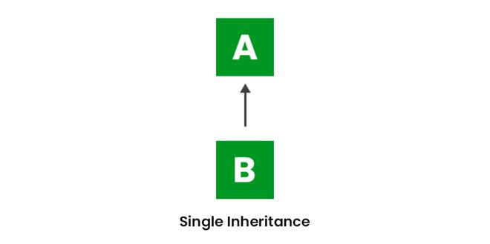

### **2. Multilevel Inheritance**

In Multilevel Inheritance, a derived class will be inheriting a base class, and as well as the derived class also acts as the base class for other classes. In the below image, class A serves as a base class for the derived class B, which in turn serves as a base class for the derived class C. In Java, a class cannot directly access the [grandparent’s members](https://www.geeksforgeeks.org/g-fact-91/).

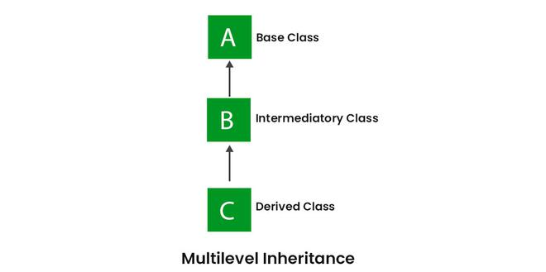

### **3. Hierarchical Inheritance**

In Hierarchical Inheritance, one class serves as a superclass (base class) for more than one subclass. In the below image, class A serves as a base class for the derived classes B, C, and D.

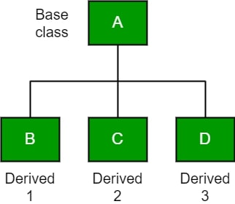

### **4. Multiple Inheritance (Through Interfaces)**

In Multiple inheritances, one class can have more than one superclass and inherit features from all parent classes. Please note that Java does **not** support multiple inheritances with classes. In Java, we can achieve multiple inheritances only through Interfaces. In the image below, Class C is derived from interfaces A and B.

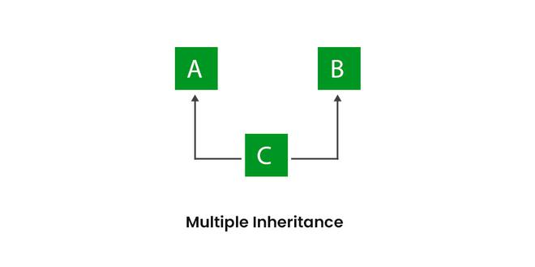

### **5. Hybrid Inheritance**

It is a mix of two or more of the above types of inheritance. It can be achieved through a combination of Multilevel Inheritance and Hierarchical Inheritance 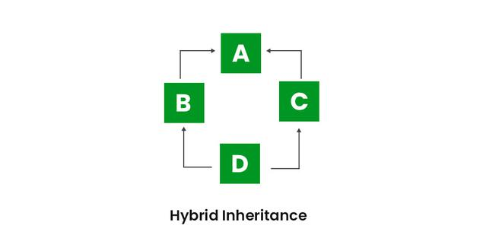

* **Default superclass**: Except Object class, which has no superclass, every class has one and only one direct superclass (single inheritance). In the absence of any other explicit superclass, every class is implicitly a subclass of the Object class.
* **Superclass can only be one:** A superclass can have any number of subclasses. But a subclass can have only **one** superclass. This is because Java does not support multiple inheritances with classes. Although with interfaces, multiple inheritance is supported by Java.
* **Inheriting Constructors:** A subclass inherits all the members (fields, methods, and nested classes) from its superclass. Constructors are not members, so they are not inherited by subclasses, but the constructor of the superclass can be invoked from the subclass.
* **Private member inheritance:** A subclass does not inherit the private members of its parent class. However, if the superclass has public or protected methods(like getters and setters) for accessing its private fields, these can also be used by the subclass.

### **Advantages Of Inheritance in Java:**

1. Code Reusability: Inheritance allows for code reuse and reduces the amount of code that needs to be written. The subclass can reuse the properties and methods of the superclass, reducing duplication of code.
2. Abstraction: Inheritance allows for the creation of abstract classes that define a common interface for a group of related classes. This promotes abstraction and encapsulation, making the code easier to maintain and extend.
3. Class Hierarchy: Inheritance allows for the creation of a class hierarchy, which can be used to model real-world objects and their relationships.
4. Polymorphism: Inheritance allows for polymorphism, which is the ability of an object to take on multiple forms. Subclasses can override the methods of the superclass, which allows them to change their behavior in different ways.

### **Disadvantages of Inheritance in Java:**

1. Complexity: Inheritance can make the code more complex and harder to understand. This is especially true if the inheritance hierarchy is deep or if multiple inheritances is used.
2. Tight Coupling: Inheritance creates a tight coupling between the superclass and subclass, making it difficult to make changes to the superclass without affecting the subclass.